Version 1 Project Description

This project will be a program that can read pdfs (syllabi in this case), recognize and give a count for each unique term within that document. For instance, if the term “umbrella” is in the document three times, the program will return a count of “3” for “umbrella” (**1) in the output.

**1Problem – variations of a word (umbrella vs. umbrellas) – other variants as well – context may be a factor

Data input: the interface will allow users to enter data in multiple ways. Users will be able to:
- Enter their own text (i.e. typing) into the text field
- Copy/paste text into the upper text field
- Browse a local pdf to read (**2)

**2Problem – if the .pdf is scan or an image, additional modifications may need to be made in order to read those, as they wouldn’t be in a document format.

Data manipulation: the interface will allow users to specify very limited output preferences. Users will be able to:
- Choose a specific term or terms to read, count and display in the output field and/or download (**3)
- Choose which terms should not be included in the counts or output field and/or download (**3)
- Choose to read and count all of the terms in a pdf and display all terms and counts in the output field and/or download

**3Problem – Multiple entry boxes or a single box with multiple terms. How to distinguish (e.g., comma, semicolon, etc.)? Is there a limit of number of terms? If so, how many terms can be entered for multiple entry?

Data output: the interface will display the terms and counts of each term in the output field and also give the user the option to download as well as copy/paste, the data shown in the output display,

Version 1 External Mechanisms Used:

- The internet
- Python packages:

    - PyPDF2
    - Counter (collections)
    - re
    - Pandas (for creating and saving an Excel file)

Version 1 Graphical User Interface (GUI)

- Desktop – likely tkinter or other UI if possible (e.g., XD, Figma, InVision, etc.)

Possible revisions or add-ons

- Ability to enter a URL for reading
- Possibly pytesseract and pillow (for image-based or scanned .pdfs)
- Possible APIs in the future – external mechanisms. Currently none exist for syllabi
- Web interface
- Total word count
- Total unique word count

Task Vignette 1:

For a typing class, User 1 has been given multiple paragraphs to type in 60 seconds. When finished, the professor has asked that the students report the number of words they typed without including the words, “and”, “for”, “of”, and “the”.

- User 1 typed their text into the text field at the top of the Syllabus Reader
- User 1 entered “and”, “for”, “of”, and “the” into the “Remove search terms” field.
- User 1 clicked the “Read it!” button.
- User 1 counted the output manually and opted to not download the results.

Task Vignette 2:

For a literature class, User 2 has been given an online passage to read and has been asked to find each instance of the word “light” and its contextual meaning in each instance.

- User 2 copied the text from the online passage and pasted it into the text field at the top of the Syllabus Reader.
- User 2 entered the word “light” into the “Enter search terms” field,
- User 2 clicked the “Read it!” button.
- User 2 counted the output manually and opted to not download the results.

Task Vignette 3:

User 3 is reading syllabus pdfs for their thesis research.

- User 3 clicked the “Find doc” button beneath the text field at the top of the Syllabus Reader
- User 3 clicked the “Read it!” button.
- User 3 clicked the “DOWNLOAD” button to download the results to an Excel file.

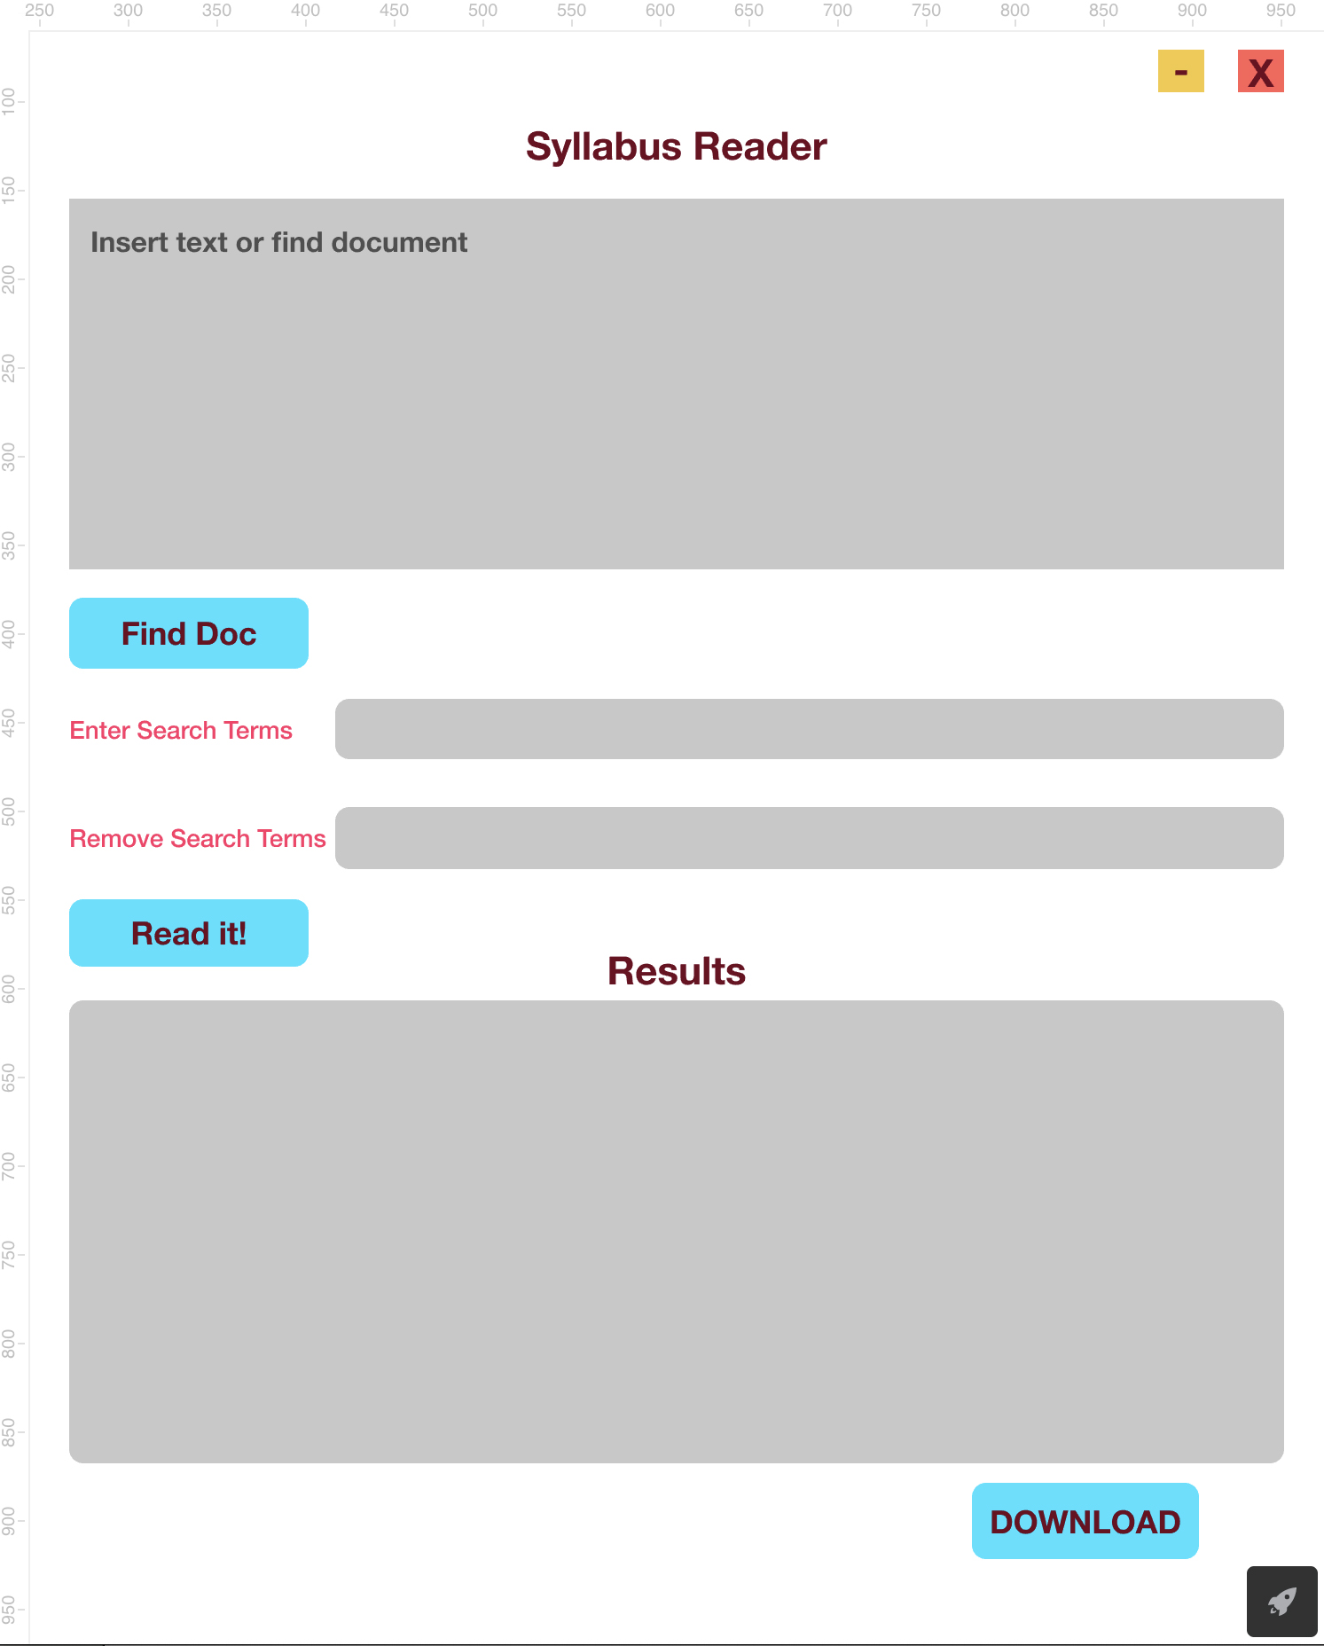

Fig. 1 Syllabus Reader diagram

Github Link
https://github.com/AC584/Syllabus-Reader
Data structures: - pandas dataframe, each containing data about each word (word, count) that's been counted in the pdf
Core functions:
- def search_pdf():
  - User interaction (enter search or remove items)
  - Input
  - used to find specific terms in document
  - possible to also use to search omitted terms?

- def count_all_words_in_pdf():
  - User interaction (“Read it!” button
  - Input and Output
  - counts all words in a document
  - returns a pandas dataframe for display or download

- def count_word_in_pdf():
  - User interaction (with search or remove functions)
  - Input and Output
  - counts searched words in a document
  - counts words in a document minus the omitted terms
  - returns a pandas dataframe

- def extract_and_count_terms_from_pdf():
  - User interaction (“DOWNLOAD”)
  - Input and Output
  - extracts pandas dataframe (word and counts)
  - delivers dictionary to Excel file

Final (self) assessment

- After working through the spec, what was the biggest or most unexpected change you had to make from scratch?
  - Variations of a word
  - That the document may not be readable for some reason

- How confident do you feel that you can implement the spec as it’s written right now?
  - Somewhat confident. I believe I understand the pieces, it’s just a matter of thinking and trial and error at this point.

- What is the biggest potential problem that you NEED to solve (or you’ll fail)?
  - I don’t think I know yet.

- What parts are you least familiar with and might need my help?
  - Again, I don’t think I know yet, but likely many things.

